Eg: Jdbc_Example

✅ 1. Why we use THREE separate try blocks inside finally?
(Because we are closing three resources: ResultSet, Statement, Connection)
If you write one try block like this:
try {
if (resultSet != null) resultSet.close();
if (statement != null) statement.close();
if (connection != null) connection.close();
} catch (SQLException e) {
...
}

❌ What happens if resultSet.close() throws an exception?
- Program jumps directly to catch
- statement.close() will NEVER run
- connection.close() will NEVER run
- Result:
  - Statement remains open
  - Connection remains open → major connection leak
  - Application may crash later (no DB connections left)
So one try block is unsafe when closing multiple JDBC resources.

✅ 2. Why THREE try blocks are used (PROFESSIONAL PRACTICE)
We close each resource independently:
try { resultSet.close(); } catch (...) {}
try { statement.close(); } catch (...) {}
try { connection.close(); } catch (...) {}

✔ What this gives you?
- If resultSet.close() fails → statement.close() still runs
- If statement.close() fails → connection.close() still runs
- Every resource gets its own chance to close
- Prevents connection leaks
- This is the pattern used in professional Java JDBC code

❗ Memory efficiency & compilation time DO NOT improve
Using one try block instead of three:
- ❌ does NOT reduce memory
- ❌ does NOT make code faster
- ❌ does NOT reduce bytecode in any meaningful way
- ❌ does NOT improve performance

JVM does not care whether you write:
- 1 try block
- 2 try blocks
- 3 try blocks
- even 10 try blocks
The difference is almost zero in terms of performance.

❗ Why?
Because:
- try is not an object → no memory allocation
- try blocks only generate a few extra bytecode instructions
- close() itself is extremely fast (microseconds)
Safety is more important than micro-optimizations.

✅ 3. Do THREE try blocks waste memory?
Absolutely NO.
- try-catch does NOT allocate memory
- JVM does not load extra objects
- The difference in bytecode is negligible
- No performance penalty for multiple blocks
This is why every JDBC tutorial and company code closes each resource separately.

⭐ Final Summary (Best for Revision Notes)
Approach | Safe? | Will all resources close if earlier one fails? | Industry Standard?
One try block for all (❌) | ❌ No | ❌ No | ❌ Never used
Three separate try blocks (✔) | ✔ Yes | ✔ Yes | ✔ Always used

🧠 Memory Tip:
Each resource must get its own try-catch because one failure should not stop the others from closing.
Assume your try block has 4 lines:
try {
line1
line2
line3
line4
}
catch (...) {
handle exception
}

code_after_catch;

✅ CASE: Exception occurs at line1

What happens?

✔ 1. Line1 throws exception

✔ 2. Java IMMEDIATELY jumps to catch

❌ 3. line2, line3, line4 → will NOT execute

✔ 4. catch block runs

✔ 5. If catch handles exception properly → program continues

✔ 6. Any code after catch WILL execute (like next try, next statements)

⭐ Visual Flow Diagram
try {
line1 → EXCEPTION ❌
line2 → skipped ❌
line3 → skipped ❌
line4 → skipped ❌
}
catch → executes ✔

code_after_catch → executes ✔

⭐ Your exact statement:
if exception occurs at line 1 control goes to catch block.
the lines below 1 in try block will not execute.
and if the catch block handles it properly then code after catch will execute.
and if there is another try or any code below catch, that will execute.

✔✔✔ This is 100% correct.

⭐ Memory Tip (Very Simple)
TRY stops at the line where exception happens.
CATCH runs.
After catch → program continues normally.

Note:
Using the ResultSet object, we can retrieve the column values by using column names also, not only column numbers.
This improves readability, reduces mistakes, and makes the code look more professional.
Integer id = resultSet.getInt("Id");
String name = resultSet.getString("Name");
String dept = resultSet.getString("Department");
Integer sal = resultSet.getInt("Salary");
String gen = resultSet.getString("Gender");
Integer age = resultSet.getInt("Age");

Example: Jdbc_Example2

✅ SQL Command Categories — As per DBA Specification
According to a DBA (Database Administrator), all SQL commands are divided into the following types:

a. DDL – Data Definition Language
Commands that define or modify database structures.
Examples:
- CREATE TABLE
- ALTER TABLE
- DROP TABLE

b. DML – Data Manipulation Language
Commands used to modify data in tables.
Examples:
- INSERT
- UPDATE
- DELETE

c. DQL – Data Query Language
Commands used to retrieve data.
Examples:
- SELECT

d. DCL – Data Control Language
Commands used for controlling access and permissions.
Examples:
- Change passwords
- Grant or revoke access

e. DA Commands – Database Administrator Commands
Commands used by DBA for database management.
Examples:
- START AUDIT

f. TCL – Transaction Control Language
Commands for handling transactions.
Examples:
- COMMIT
- ROLLBACK
- SAVEPOINT

✅ SQL Classification — From Java Developer Point of View
For a Java developer, SQL operations are simply grouped into two categories:

a. Select Operation
- Includes: Only SELECT
- Output: Returns a ResultSet (multiple records)

b. Non-Select Operation
- Includes: INSERT, UPDATE, DELETE, CREATE, ALTER, etc.
- Output: Returns number of rows affected

✅ Executing SQL Using Statement Object
To run SQL queries in JDBC, Java provides three methods:

1. executeQuery()
- Used only for SELECT operations.
- Returns a ResultSet (set of records).
Method Signature:
public ResultSet executeQuery(String sqlSelectQuery) throws SQLException;
Example:
ResultSet resultSet =
statement.executeQuery("select sid, sname, sage, saddress from student");

2. executeUpdate()
- Used for Non-Select operations (INSERT, UPDATE, DELETE, and DDL commands).
- Returns an int representing how many rows were affected.
Method Signature:
public int executeUpdate(String sqlNonSelectQuery) throws SQLException;
Example:
int rowAffected =
statement.executeUpdate("delete from student where sid = 10");

System.out.println("No of rows affected is :: " + rowAffected);

3. execute()
- Used when the query type (select or non-select) is not known in advance.
- Returns boolean:
  - true → SELECT query
  - false → Non-select query
Method Signature:
public boolean execute(String sql) throws SQLException;
Example:
boolean value = statement.execute(dynamicQuery);

if (value == true) {
// SELECT query
ResultSet resultSet = statement.getResultSet();
// process the resultSet
}
else {
// Non-select query
int rowCount = statement.getUpdateCount();
System.out.println("Number of rows affected is :: " + rowCount);
}

Eg: jdbc_Execute_Update_Method
// go through the code

Eg: jdbc_Execute_Update_Method_Eg2
// go through the code

Eg: jdbc_Execute_Update_Method_Eg3
// go through the code

Approaches to Build SQL Queries Dynamically in Java
1️⃣ Approach 1 — String Concatenation

👉 Java uses double quotes " " to define a string.
This is for Java.

👉 SQL uses single quotes ' ' for string values.
This is for the database.
So inside the Java string, you will see:
- " → Java string boundary
- ' → SQL string boundary

✔ What you do
You directly join (concatenate) strings using +.

✔ Example
String sqlInsertQuery =
"insert into student(sname, sage, saddress) values ('" + sname + "', " + sage + ", '" + saddress + "')";

✔ Easy to write
But...

❌ Problems
- Very risky (SQL Injection)
- Hard to maintain
- Mistakes in quotes happen easily
- Not used in real applications

2️⃣ Approach 2 — Manually Adding Quotes Before Formatting

✔ What you do
You add single quotes to string values first, then insert into the query.

✔ Example
sname = "'" + sname + "'";
saddress = "'" + saddress + "'";

String sqlInsertQuery =
"insert into student(sname, sage, saddress) values (" + sname + ", " + sage + ", " + saddress + ")";

✔ Slightly cleaner
But...

❌ Problems
- Still unsafe
- Still manual string handling
- Still prone to errors
- Still not used in companies

3️⃣ Approach 3 — Using String.format()

⭐ Format Specifiers for All Common Data Types
Data Type | Format Specifier | Meaning
String | %s | prints text
int | %d | prints whole numbers
long | %d | same as int (both are decimal numbers)
float | %f | prints decimal numbers
double | %f | prints decimal numbers
boolean | %b | prints true/false
char | %c | prints a single character

✔ What you do
You use placeholders (%s, %d) and allow Java to place values correctly.

✔ Example
String sqlInsertQuery = String.format(
"insert into student(sname, sage, saddress) values ('%s', %d, '%s')",
sname, sage, saddress
);

✔ Cleaner than Approach 1 and 2
But...

❌ Problems
- Still string-based SQL
- Still open to SQL Injection
- Companies do NOT use this for database operations

All the above approaches are not used in the industry because of above mentioned problems instead prepared statement is used.
PreparedStatement — The REAL Industry Standard (Most Used)
✔ Why companies use this
Prevents SQL Injection
No need to add quotes
Automatically handles data types
Cleaner and maintainable
(we will go through this concept further)

Eg: Dynamic_Input_Using_String_Format_Method
// go through the code

Properties File:

Hard-Coded Values Inside Java (Without Properties File)
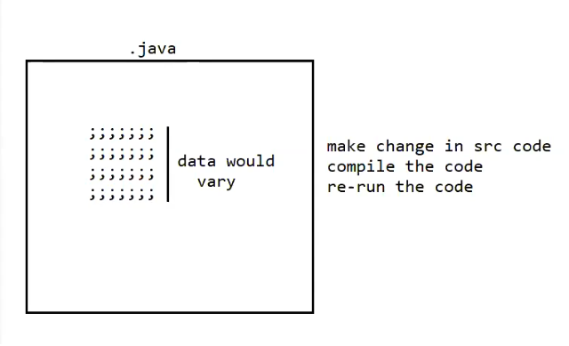
Inside .java file, you directly write values like:
url = "jdbc:oracle:thin:@localhost:1521:orcl";
username = "practice";
password = "1234";

❗ Problem
If these values change frequently, then every time you must:
1️⃣ Change the Java source code
2️⃣ Compile again (javac)
3️⃣ Run again
This is slow, painful, and not recommended for real-time projects.

Using Properties File to Store Frequently Changing Data
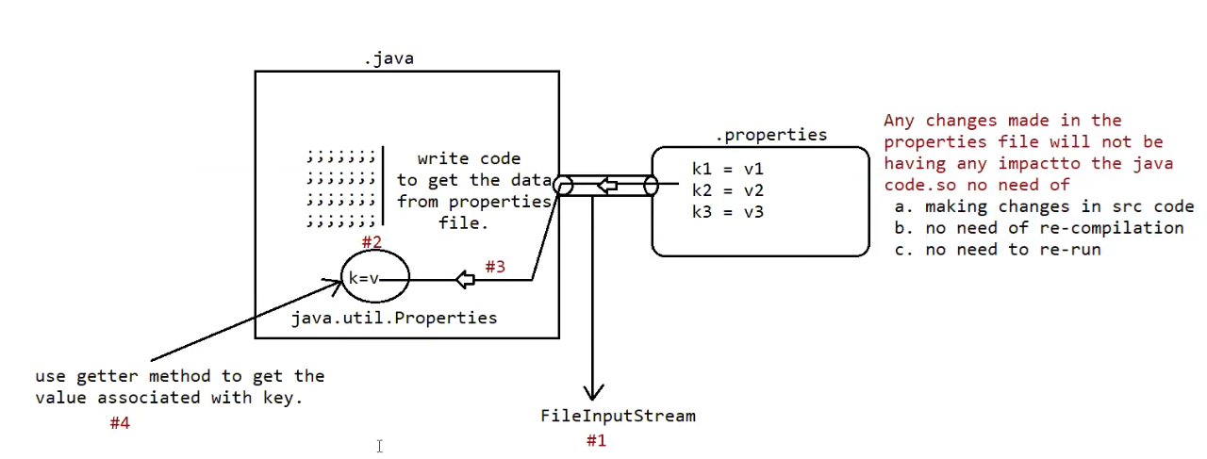
Now, instead of writing data inside the .java file, you put it in a separate file:

🔹 config.properties
k1 = v1
k2 = v2
k3 = v3

Your .java file now contains only logic, no changing data.
Java reads these values from the .properties file at runtime.

⭐ Step-by-Step Flow (Exactly Like Numbers in Your Diagram)

#1 Load the properties file
Java opens the file using:
FileInputStream fis = new FileInputStream("config.properties");

#2 Create a Properties object
Properties p = new Properties();

#3 Load the file data into the Properties object
p.load(fis);
Now p contains:
k1 → v1
k2 → v2
k3 → v3

#4 Get the value using the key
String value = p.getProperty("k1");

🧠 Why Companies Use Properties File (Your Red Text Explanation)

✔ No need to change Java source code
Data is outside the .java file.

✔ No need to recompile
Because you did not touch Java code.

✔ No need to re-run the program
Just restart or reload the configuration.

✔ Configuration becomes flexible
Useful for:
- DB username, password
- URLs
- API keys
- File paths
- Feature flags

💡 Super Simple Memory Line
Properties file = Changing data outside Java code.

🎁 Final Notes (Very Simple English)

✔ Properties file stores data as Key = Value
Example:
server = localhost
port = 1521
username = practice
password = 1234

✔ java.util.Properties is a special object
It is designed only to hold key–value pairs.

✔ If the data changes frequently → ALWAYS use a properties file
Otherwise, your code becomes heavy and hard to maintain.

Eg: Properties_Example_With_Java_Program
// go through the code

Eg: Properties_With_Select_Operation
//go through the code

